**AR VR ASSIGNMENT**

**Task 1 : Set up unity project**

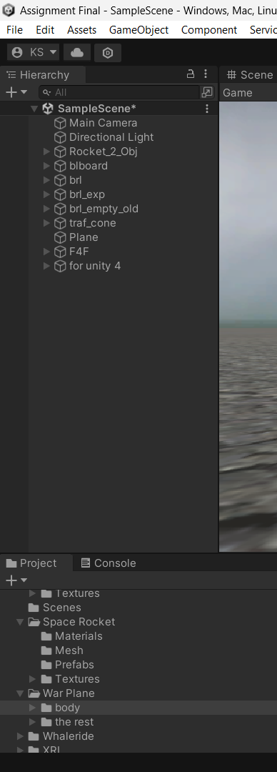

**Task 2 : create the ground plane**

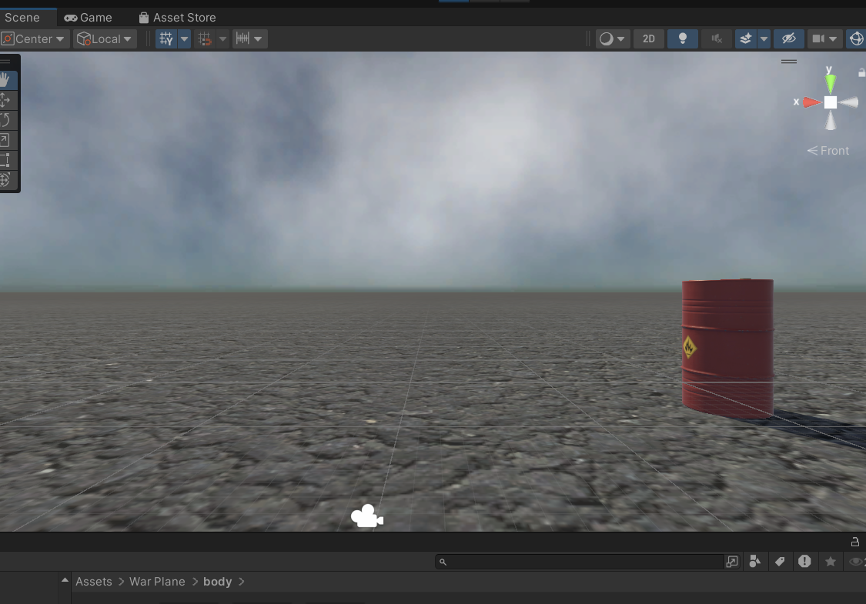

**Task 3 : Add a sky box**

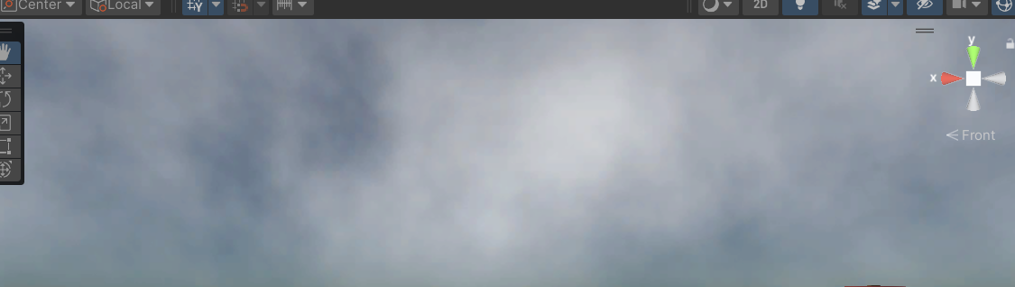

**Task 4 : ADD environment objects**

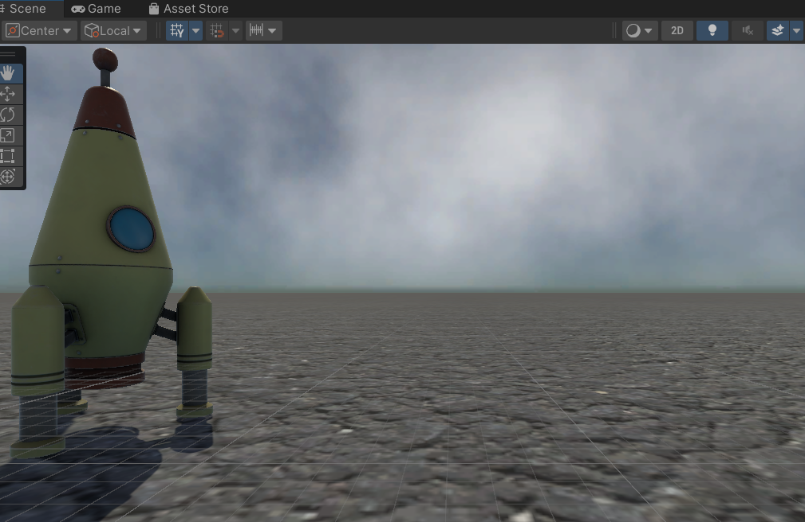

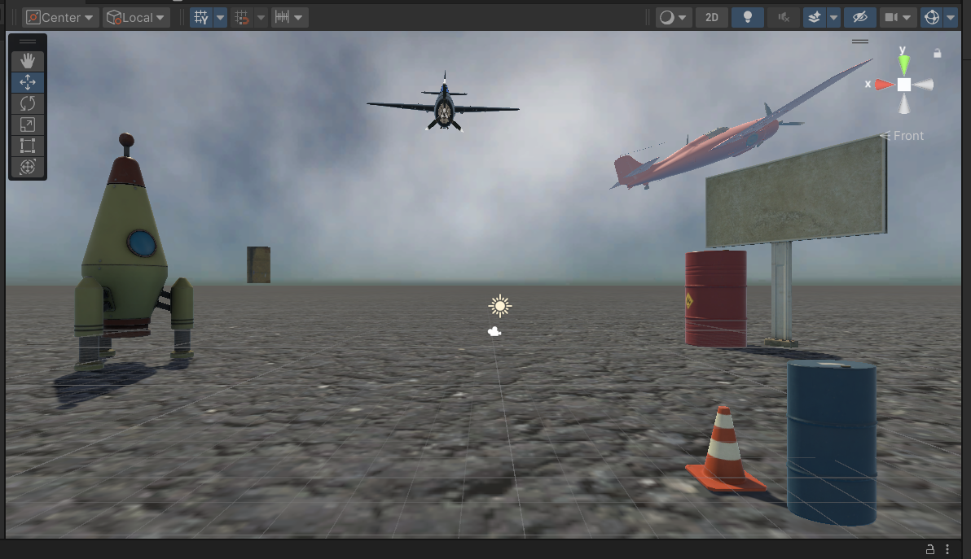

**Task 6 : lightening and shadow**

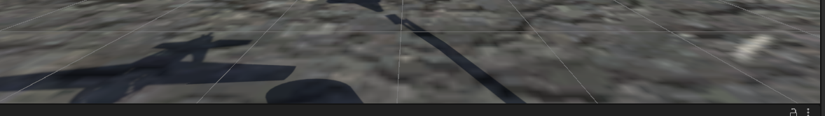

**Task 8 : grabable object**

